**Code Smell – 2**

**Shotgun Surgery**

This code smell occurs when a change needs to be made and then a lot of other classes need to be touched.

**Code Location:**

The classe is in the folloying path:

“src/main/java/org/jabref/model/entry/field.StandartField”

**Code Snippet:**

As we saw in the dependency metrics (Dpt metric) the class StandardField has a lot of dependents (322).

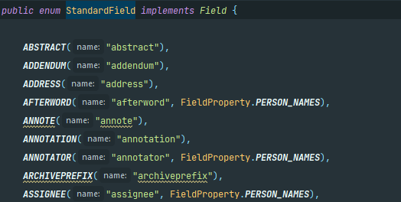

An example of a dependency in class FieldsFactory:

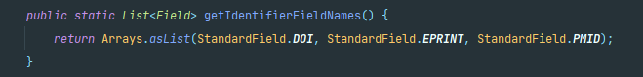

**Justification:**

As explained above, the StardardField have a lof of dependents and if we to change this class we might have to change some of the 322 classes in question.

**Refactoring proposal:**

This code smell inidicates that we should reduce the amount of methods in different classes, but we should be careful not to move too many methods to just a few methods. We should do that beacause the class StandardFields have 322 dependents.